This document provides a step-by-step walkthrough for approving courses once they have been created. Generally, there are one to two levels of approval. This document provides instructions for each process. Your portal view will reflect your district’s specific naming convention and configuration choices.

# Course Approval Process: Single Level of Approval

* Log onto your portal and click the **Course Approval** tab. Your labels may differ depending on the district’s configuration choices.



* In the **Administration** channel, click the **Course Approval** **Administration** link.

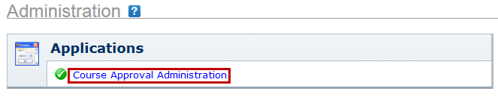

* On the **Course Approval Workflow** screen, click the **Submitted Courses** link on the **Workflow Admin** menu to the left, or click the same link under the .**Course Approval Home** channel.

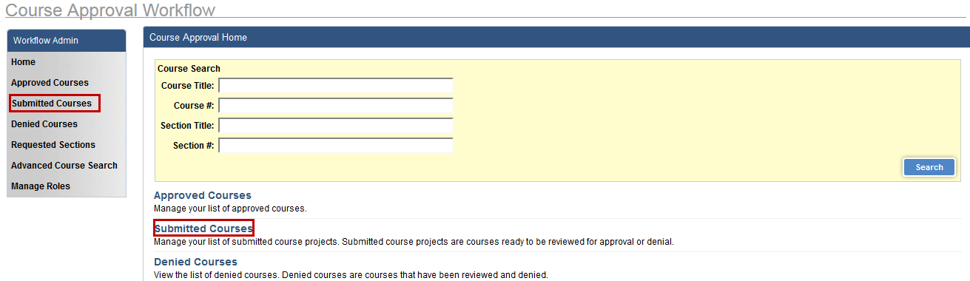

* Click the **Actions** button and select **Review.**

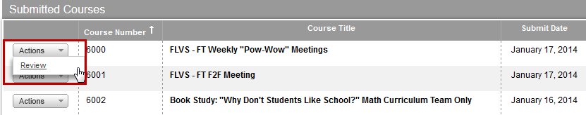

* Click **Review Course** to review the course.

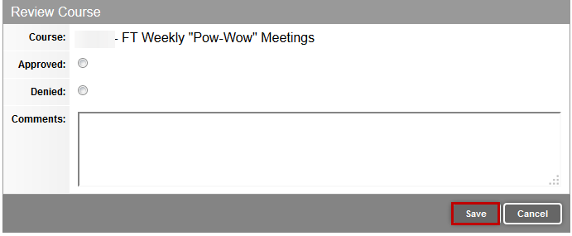

**Note:** The status key to the right indicates the status of the course in the approval process.

* Check the radio button to indicate whether the course is **Approved** or **Denied.**
* If the course is **Denied**, enter an explanation in the **Comments** field.
* Click **Save** when finished**.**

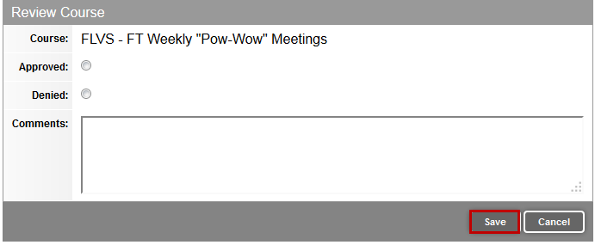

.

* For instructor-led courses, scroll down to **Course Detains.** To the left of **Sections,** click **Review.**

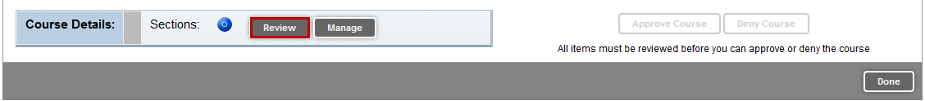

* Follow the same process, and if the course is denied, enter an explanation into the comments field.
* Click **Save Status** when finished.

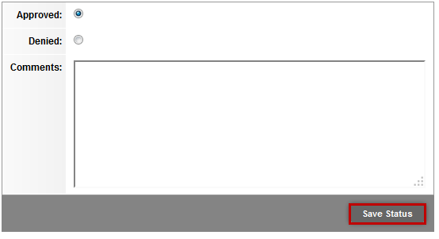

* Scroll to the bottom of the screen and click **Done** on the lower right side of the screen.



* On the Review Course screen, click Approve Course.

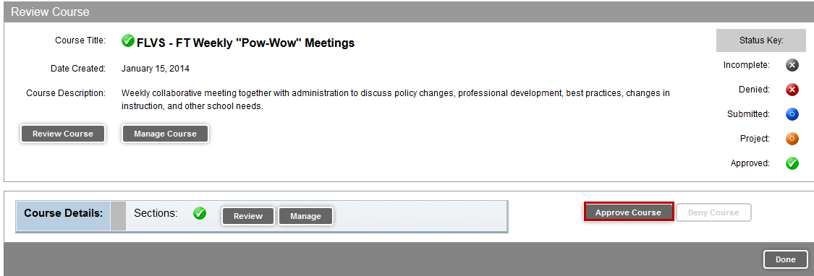

* Click **OK** in the pop-up box to indicate you want to approve the course and release it to the catalog.

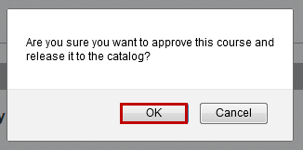

# Course Approval Process – Two Levels of Approval

If the **Course Approval** process has an additional step, a second reviewer will need to approve the course and any associated sections.

* Log onto your portal and click the **Course Approval** tab. 
* In the **Administration** channel, click the **Course Approval** **Administration** link.



* Follow the same process to approve courses and associated sections.